

Jue Jun Ma

1014477 V1.0

CMIDAT01K Project

Documentation

Contents

Introduction 3

Relevant prior projects 3

Process 3

DHT11 3

LCD screen 4

Thingspeak 5

Fan 5

Outcome 6

Next steps and future directions. 9

Parts list 9

# Introduction

As IoT-Project I made an automatic fan and temperature and humidity meter. It displays on a 16x2 LCD screen what the temperature and humidity levels are in the area, turn on a fan to cool you down, and shows the number of times the fan has turned on and sends that data to Thingspeak so you can see what the temperature and humidity level is and how many times your fan has turned on from anywhere with an internet signal. I wanted to make a temperature and humidity meter and an automatic fan because my room gets way hotter or colder, depending on the weather outside, than the rest of my house so I wanted to exactly know how hot or cold it is in my room. I can also use the meter for my 3D printer filament too to check how humid it is where I store my filament so I can prevent my filament from getting damaged. And I can also use it to check how hot the air from my bitcoin miner is because I am curious and I don’t have a thermometer home so this can be handy and it’s way more fun to make something instead of buying it.

# Relevant prior projects

I have never touched a raspberry pi before this class. I have learned to program in python in the first two periods of this school year and have done a project in python making a digital extension for a board game we made. For the first project I made with my raspberry pi, I just made a simple code that turns on and off a led I. With this, I learned how to wire up things with a raspberry pi and what the pins do, and that I could program with python. I also made a rest thingspeak channel with the code provided in the class and figured out how thingspeak works.

How I came up with the idea is when I bought a starter kit with my raspberry pi I got a lot of sensors and I looked at the different sensors I got and at first I found a proximity sensor so I could make an alarm or something but then I saw a Temperature and Humidity sensor(DHT11) and I thought that I could use that more because my room gets hotter or colder than the rest of my house depending on the climate so I just wanted to know what the difference is between my room and the rest of the house. And then I thought I could also use this for my 3D printing filaments to check if the humidity levels aren’t too high that it could damage my filaments. Later I was looking through my starter kit and found a 16x2 LCD screen and thought it would be cool to show the temperature and humidity on a screen as well and not only on thingspeak.

# Process

I looked at what I wanted to make and made a list in my head for what I needed and I planned to do the DHT11 sensor first so I could read the data and then I could display it on my screen and after that, I would send that information to thingspeak. I programmed everything in visual studio code because I am familiar with it. As an IoT platform, I chose Thingspeak. It was the only one I knew because it was shown in class and I didn’t have prior experience with IoT.

## DHT11

First I connected my Raspberry Pi 4 to a breadboard using a GPIO extension board then I looked up how to wire up the DHT11 and how to read the information from the DHT11. First I used the Adafruit_DHT library but it’s an outdated version so I used Adafruit_CircuitPython_DHT and I needed to change some stuff in my code. So reading the temperature and humidity went from

Import Adafruit_DHT

dhtDevice = Adafruit_DHT.DHT11

humidity, temperature = Adafruit_DHT.Read(dhtDevice, 4)

to

import adafruit_dht

import board

dhtDevice = adafruit_dht.DHT11(board.D4)

temperature = dhtDevice.temperature

humidity = dhtDevice.humidity

With the Adafruit_DHT I got an error saying “cannot import name 'beaglebone_black_driver' from 'adafruit_dht'” I found a workaround buy I needed to change something in the file of Adafruit_DHT and didn’t want to do it because if I reinstall Adafruit_DHT it would change back I think. So I found Adafruit_CircuitPython_DHT and first It couldn’t detect my sensor so I looked up the wiring and found out I had my power and data cables flipped so I fixed that and got a lot of runtime errors but I found out that if you ignore the errors sometimes it does read the temperature and humidity so I put in a try-except and when it got a runtime error I just passed it.

## LCD screen

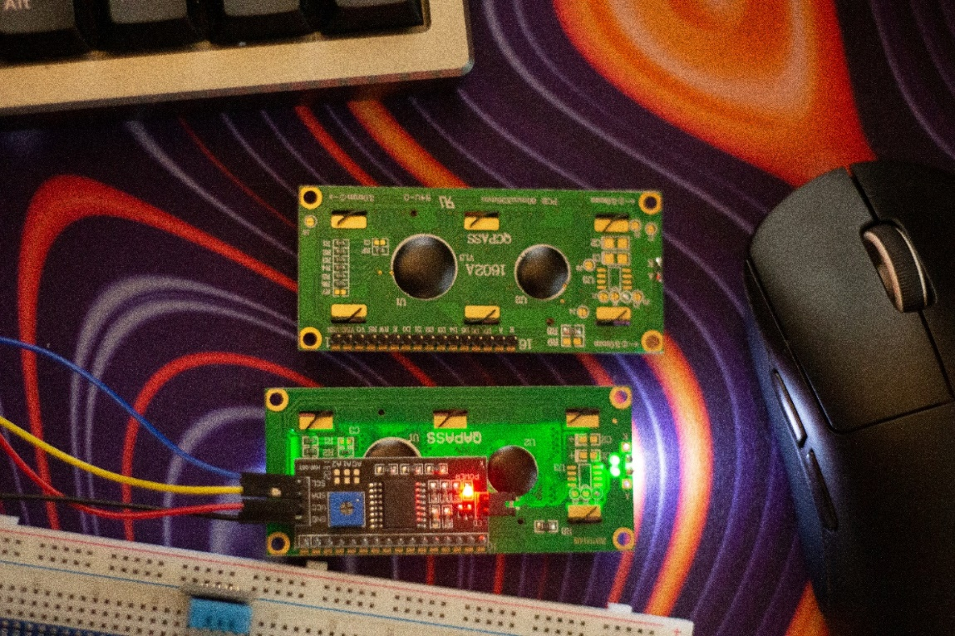After I got the DHT11 working I started to work on the LCD screen and I had 2 types one with a board soldered onto it and another with just a lot of pins as you can see in this picture.

So I looked up the difference and found that the screen with a soldered on board was an I2C LCD screen and thought that would be easier because it had fewer pins. After I made a choice I started to look at how to wire it up and how to show text on the LCD first I figured out how to wire it up and then I found some demo code for the screen and looked at how they worked but they use an extra python file to run it so I started to look for libraries. I found a library called rpi_lcd and It worked so I used it in my code it was easy to use. To show some text on your screen to do it you just do

#you don’t have to do “as LCD

import rpi_lcd as LCD”

lcd = LCD()

#Print something to the first line of the screen

lcd.text(“First line”, 1)

#print something to the second line of the screen

lcd.text(“Second line”, 2)

At first, I didn’t see anything on my screen and found out that you needed to turn the screw on the back of the soldered on board and then I saw the text. I found out that if you exit the program using a keyboard interrupt the LCD screen doesn’t clear itself after exiting the program so I figured out that you need to do an except KeyboardInterrupt and then do lcd.clear() (it clears the screen).

## Thingspeak

After I got the LCD screen working I started to look at how to use thingspeak. First I made a channel and then I looked at how to send data to thingspeak it was pretty confusing for me because the demo code didn’t make sense in my head after a while I made it work. And it started to show the data on the thingspeak website.

## Fan

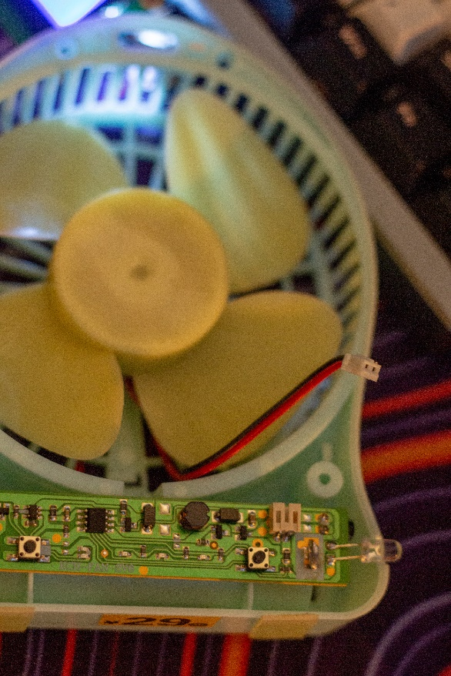After I finished I came up with the idea to add a fan to it so if it gets too hot it will turn on the fan to cool you down. I disassembled a fan I had laying around and saw that it only used a 2 pin connector in which I could connect wires easily. First I tried to power the fan with a gpio pin but found out it didn’t have enough power to run a fan but a 5v and 3.3v pin worked. I tried to find if there was a way to turn off and on a power pin but you can’t do that so I looked through my parts and found a relay and it took me some time to find out how to wire a relay up but I eventually got it and I now have a way to turn of and on a fan or any other device first I powered the relay with an external 9v battery hooked up to a power supply module for a breadboard then I figured I might as well use the power pin from the raspberry pin and so I did and it worked. Then I thought it would be cool to count the number of times the fan turns on. I added a counter and every time it turned on it would add to the counter, but when I ran the code it would count every time the function was called so I added to the if statement to check if the pin was powered off first and then add to the counter. After I did that I noticed if I would stop the code the counter would go back to 0. I would record the counter to thingspeak so I thought I could just pull the latest counter data from the website to continue the counting and it worked on the first try which I was very happy about. After 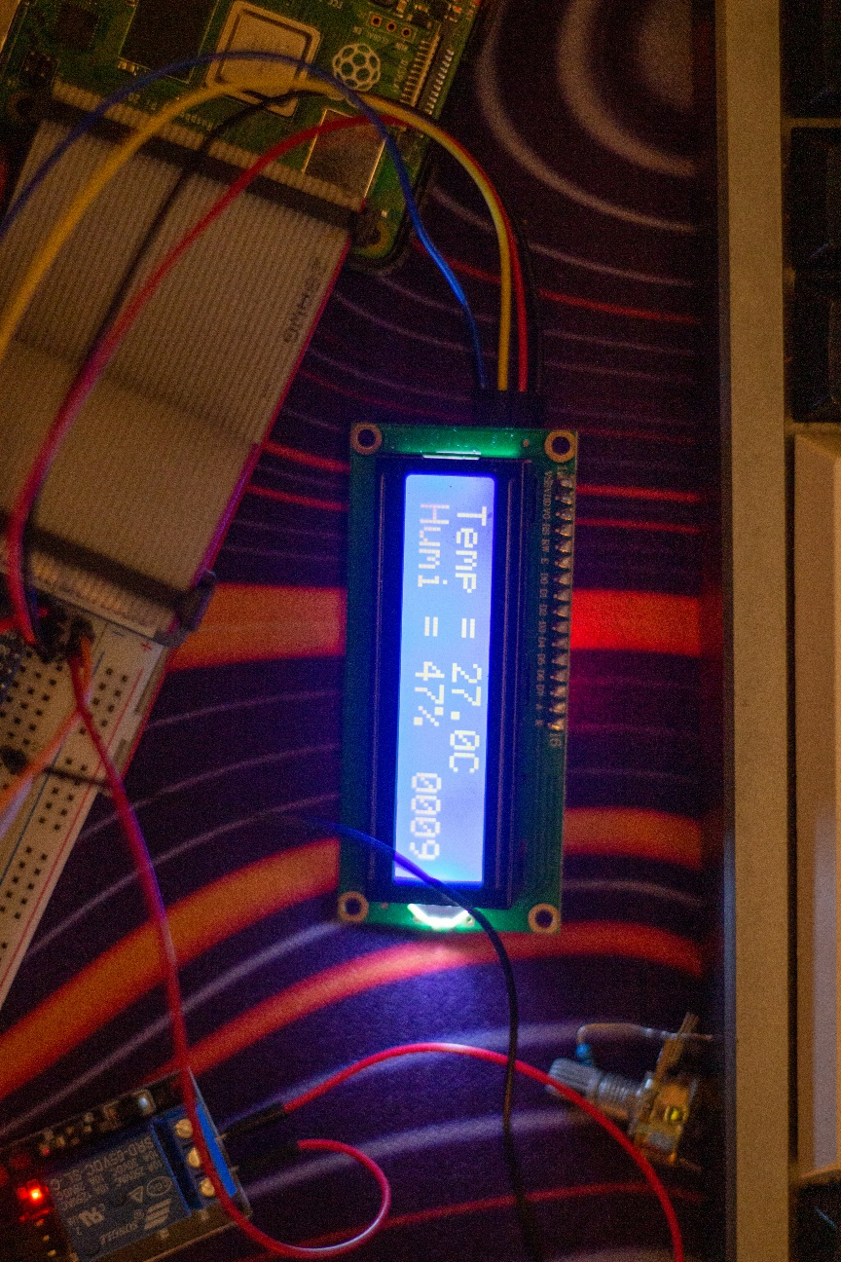that, I thought to myself how I would go about and reset the counter so I added a Boolean variable and an if statement to check if the variable was true. If the statement was true it would continue counting and if not it would be 0. Then after some more thinking I thought it would be cool to add a counter to the bottom right so I did it. And I added that if you exit the program that the output for the fan turns off so it doesn’t keep spinning after exiting the program.

# Outcome

How my project works is when you start the program it grabs the counter of how many times the fan has started up first. Then It takes the information of the temperature and humidity sensor and then checks if there are any errors or if the information is None. After checking if there aren’t any errors or None data, it prints the temperature and humidity levels out into the terminal. Then it displays it on the LCD screen and after that, it calls the function ThingspeakWrite with the temperature and humidity so it can upload it to the thingspeak website along with the fan counter. After that is complete it will check what the temperature is and if it’s high enough to turn on the fan. You can change the threshold by changing the TempThreshold variable. It also checks if the pin is already turned on or not, if not it will turn on the fan and add to the fan counter. And if the temperature is lower than the threshold it will turn the fan off. And then it will pause the code for the set amount of time decided by the variable pauseDuration you can change the number of seconds by replacing the 2 with and amount of seconds you would like. To close the program you just press control + c. If you exit the program with control + c it will clear the LCD screen and turn off the fan if it was running, otherwise, the LCD screen will still show the temperature, humidity, and counter and if the fan was running it would keep running. My plan changed a few times first I just wanted a temperature and humidity sensor so I could look at how hot it was in my room compared to the rest of my house then I added an LCD screen to it to display the temperature and humidity. To figure out how to use the screen was difficult but I did it. I didn’t need to add a lot more code to it, it was just displaying the text. After that, I added a fan to cool me down if it goes above a temperature. This was more difficult I needed to find a way to turn off and on a fan and I went through some trial and error and then I found a relay. It took a while to find out how to use a relay but I got there and to turn on and off a fan I just needed to add a new function and give it the temperature. And then I thought it would be cool to see how many times the fan has turned off and on. First I just added a counter but it kept going up every time the function was called so I just added a check to look if the fan was already turned on and then the counter worked. And after that, I send that information to thingspeak and just added an extra key-value pair to the query dictionary. After that, I made a function to read the last entry for the counter every time the program started and made the fan counter that entry. And those were all the changes in my plan. Below you can see some pictures and a wiring diagram I have the wiring diagram as a separate file on my GitHub and a video of the project working.

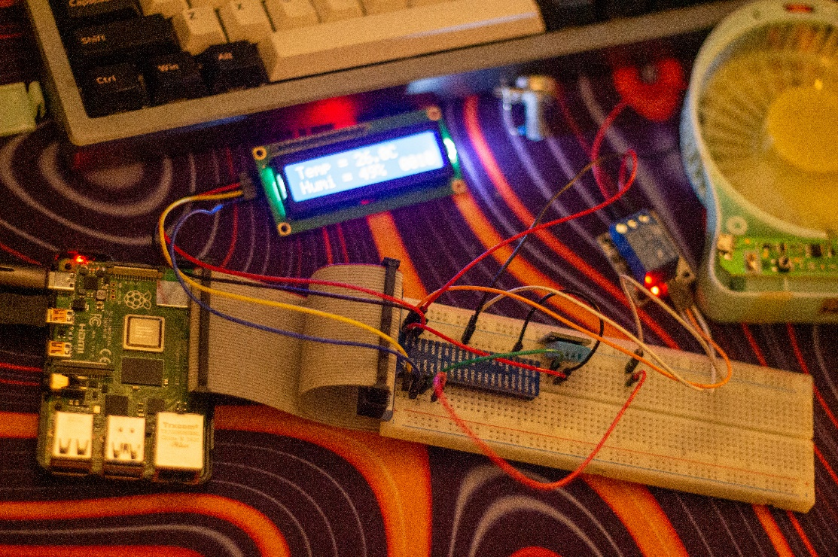

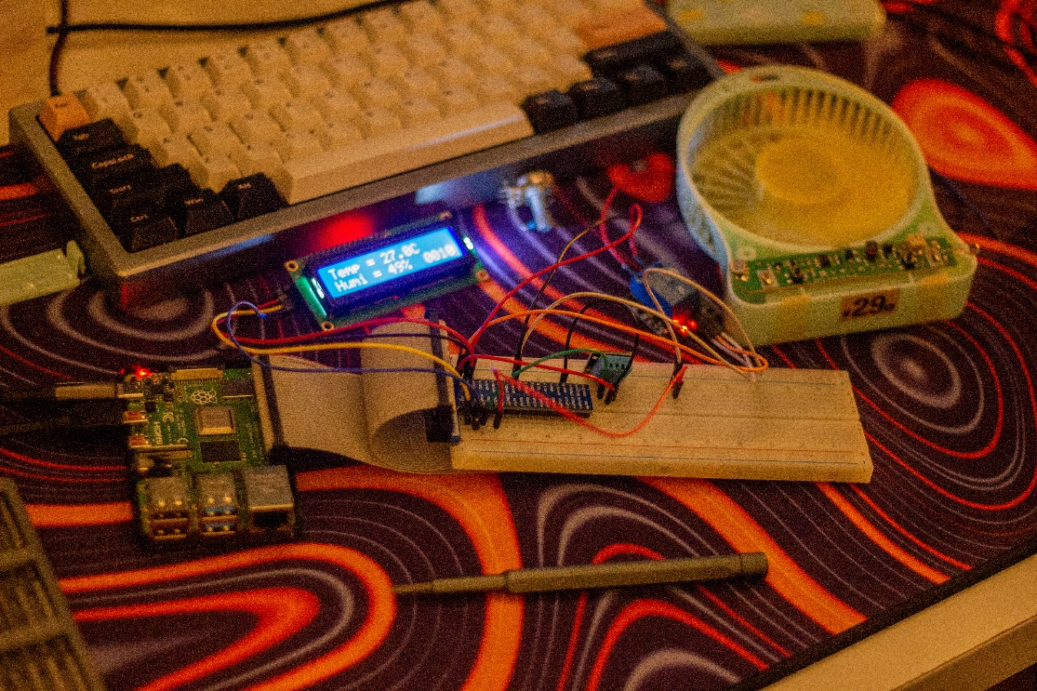

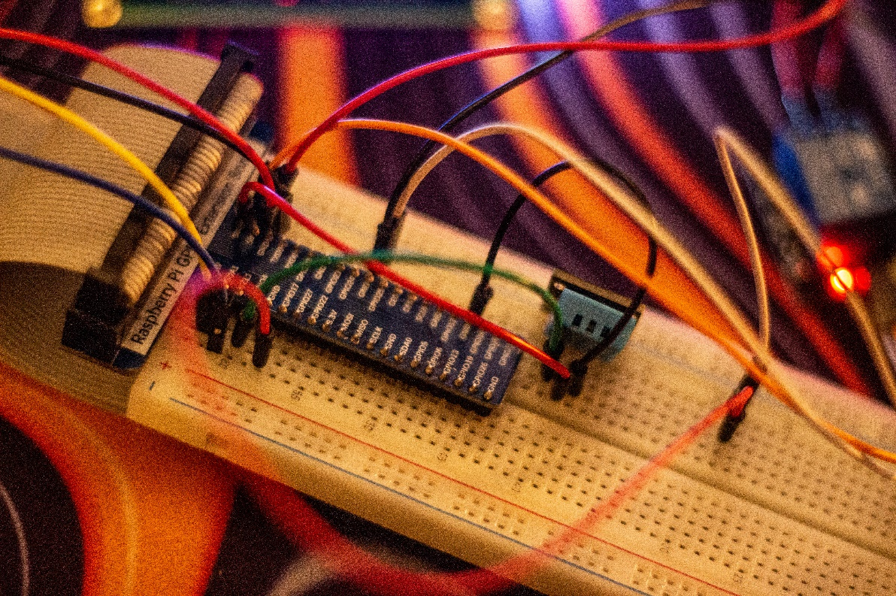

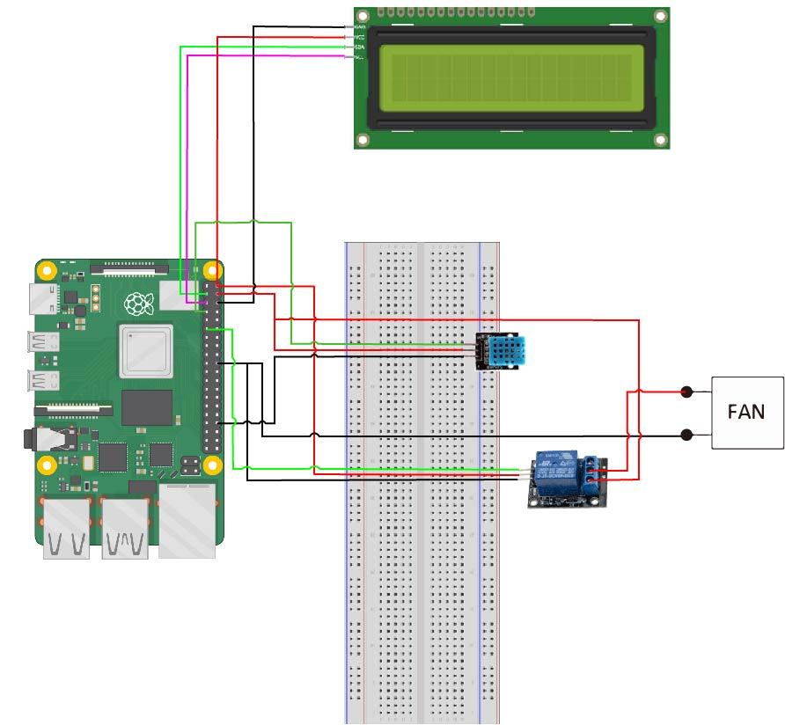

This is my wiring diagram. I used a GPIO extension board but didn’t know how to show it in a wiring diagram so I just made it as if I didn’t use a GPIO extensions board.

# Next steps and future directions.

What I could do with my project is hooking it up to a temperature controller, heater, or ac unit to automatically cool down or warm up the room or vent out warm air with a fan. This can be help full if in a room or enclosure with a 3d printer because you can control the environment of the 3dprinter. My 3D printer is in my room which if it gets cold the 3d prints don’t stick to the 3d printer bed and the edges of the 3d print curls up. You can also use my project to control a greenhouse’s temperature or humidity if you remove the fan and hook up their climate control unit. I could also put this in a container where I store my 3d filament to check the humidity level to see the humidity level and I can also add a dehumidifier to lower the humidity level in the container because the 3d filament could be damaged by high humidity levels.-

# Parts list

* 1x Raspberry Pi 4 Model B
* 1x GPIO extension board
* Wires
* 1x 3 pin DHT11
* 1x 5V relay module SRD-05VDC-SL-C
* 1x I2C 16x2 LCD
* 1x Fan with 2 pins